Feasibility Study of an Orbital Debris Removal Mission

Jean-Christophe Khou, Guillaume Lorin, Yue Jiao, Ben Morrissey, Zhongyan Bi, Murtaza Lokat, Andrius Sukys

*Abstract*—The Low Earth Orbit (LEO) region of space (160-2000km) has become densely populated with space debris, consisting primarily of inactive satellites and spent rocket stages. It has also been concluded that even without further launches, the debris problem will worsen exponentially due to collision occurrences of objects already in orbit. Studies have found that the removal of a minimum of 5 objects per year is enough to stabilise the debris problem. As such, this report is a feasibility study of an active debris removal mission aiming to remove 5 SL-8 rocket bodies using a low thrust, electrically propelled satellite. The satellite will be placed into orbit by a Falcon-9 rocket, launched from Vandenberg where it will rendezvous and deorbit each object independently. The expected delta-v for this mission is 10161m/s within a timeframe of 87 days.

# INTRODUCTION

The Low Earth Orbit (LEO) region of space has become densely populated with space debris, primarily in the form of defunct satellites, rocket bodies and smaller debris particles. There are currently 15,000 trackable objects in space whereas only 6% of these are active, functioning satellites [1]. The rest, categorized as space debris, poses a significant risk due to collisions which can damage and destroy active satellites as well as posing a serious danger to manned spaceflight. A number of studies have concluded that a critical density exists, where even with no further launches the amount of debris will increase due to collisions (Kessler Syndrome), and that this critical point has already been reached in LEO [2] [3]. As such, there is a necessity to employ Active Space Debris Removal (ADR) methods to lessen the risk of collisions and reduce the overall mass of space debris in orbit. It has been concluded that a mitigation strategy of removing a minimum of 5-10 space debris objects, by placing them in low orbits with a maximum of 25 years’ decay time, per year will be sufficient in stabilizing the debris situation [4].

Based on this research, the aim of this project was to perform a mission feasibility study on a satellite system capable of deorbiting 5 rocket stages to an orbit with a decay lifetime of less than 25 years. Rocket stages are chosen due to their relatively large size, meaning a higher risk of collision causing a larger debris field, and due to their uniform, sturdy structure which allows for docking and deorbit manoeuvres. A high delta-v requirement exists for this mission due to the need for a large amount of orbital manoeuvring, as such the mission is to be based on electrical propulsion methods giving a higher efficiency [5].

The first task, as part of the mission feasibility section, is to identify the 5 objects which will be deorbited. Following this, the launch stage of the mission will be detailed including launch rocket selection, launch location and propellant requirements with the rocket trajectory included in the results and discussion section. The satellite design, components and transfer manoeuvring are then discussed with the relevant manoeuvring parameters, delta-v budget mission costs outlined in the results and discussion section.

# Mission Feasibility Study

## Debris Identification and Selection

Extensive research and study has been performed in the area of selecting the most important, or critically relevant, debris for ADR missions. Many of the research papers completed to date come to differing conclusions on suitable debris selection, factors such as impact probability, mass, orbit lifetime and type of orbit are all considered. A focus has been placed on critical regions in higher altitudes, where there exists the highest risk of collision due to debris density and where the debris has a higher decay time. The critical regions fall within the following altitude and inclination (i) bands [1];

* 1000km ± 100km at i=82±1º
* 800km ± 100km at i=99±1º
* 850km ± 100km at i=71±1º

Following a review of available data, the 1000km band was seen to be most densely populated with a total mass of 350 metric tons, 200 tons of which is taken up by spent rocket stages [6]. It is also the area expected to suffer from the most critical collisions over the next 200 years due to this high mass and density [7]. With this region in mind, it was also decided that the aim should be to remove the largest in mass of rockets while also selecting a single rocket family. This would facilitate the design of a single docking mechanism, as well as provide the option of multiple future missions based on the same architecture. In addition to these selection parameters, the objects need to be located in a narrow inclination and RAAN band to minimize delta-v requirements.

The chosen rocket stage for this mission analysis was the Kosmos SL-8, this selection was based on the parameters listed previously. The Kosmos is one of the most abundant spent rocket stages with 288 units in orbit, allowing for multiple missions in the future based on similar designs. Most importantly however, is the location of the Kosmos stages which fall primarily in two inclination bands (74 and 83º) and are grouped in the first altitude band of 1000km ±100km. In addition to this, there is a favourable distribution of the right ascension of the ascending node (RAAN) with a number of stages in similar RAAN, helping minimize manoeuvring time and delta-v. Using two-line elements acquired from Reference [8] , a MATLAB script was created which extracted the orbital parameters for all SL-8 rocket stages. Figure 1 shows the distribution of RAAN for each inclination.

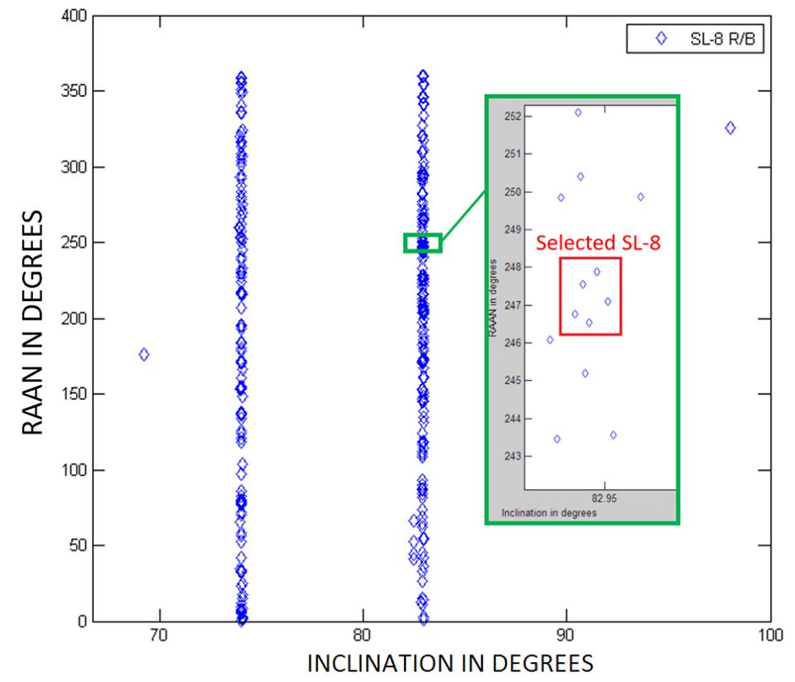

TABLE II

FALCON 9 CHARACTERISTICS

|  |  |  |
| --- | --- | --- |
| Characteristic | 1st stage | 2nd Stage |
| Specific Impulse sea level, s | 311 | - |
| Specific Impulse vacuum, s | 282 | 348 |
| Thrust, kN | 7607 | 934 |
| Payload ratio |  |  |
| Exhaust Speed, m/s |  |  |
| Burn time, s | 162 | 397 |
| Engines | 9 | 1 |
| Expansion ratio | 16 | 117 |
| Chamber Pressure, MPa | 9,7 | 9,7 |
| Payload to LEO/GTO, kg | 22800/8300 | |
| Rocket Mass, kg | 549054 | |
| Rocket Height, m | 70 | |
| Rocket Diameter, m | 3,7 | |
| Inclination Range, deg | 66-145 (Vandenberg) | |

Values taken from [23] [28] And [29]

Fig. - MATLAB plot showing the RAAN distribution for the two primary inclination bands containing SL-8 rocket bodies.

From Fig. 1, it is evident that not only do the SL-8 exhibit groupings according to inclination but there are also areas where the RAAN distribution between bodies is relatively small. In terms of delta-v and time, RAAN is the costliest orbital parameter and so it was minimized first, followed by inclination change and altitude. Five rocket stages were then selected with the minimal RAAN and inclination change, highlighted on the figure. The parameters of the chosen rocket bodies are shown in Table I.

TABLE I

SL-8 Selected Debris Objects

|  |  |  |  |  |  |
| --- | --- | --- | --- | --- | --- |
| R/B | RAAN  (°) | Inclination  (°) | Altitude perigee  (km) | Altitude apogee  (km) | Semi-major axis (km) |
| 1 | 246.5424 | 82.9425 | 959 | 984 | 7350 |
| 2 | 246.7576 | 82.9353 | 947 | 993 | 7348 |
| 3 | 247.1040 | 82.9516 | 939 | 998 | 7346 |
| 4 | 247.5517 | 82.9391 | 958 | 989 | 7352 |
| 5 | 247.8742 | 82.9464 | 963 | 995 | 7357 |

It can be seen that there is a maximum variation in inclination of 0.048° and of 1.33° in RAAN, and with an average eccentricity of 0.02 their orbits are assumed circular. The stages have an estimated dry mass of 1400kg, a length of 6.5m and a diameter of 2.4m [9].

The position of debris on their orbit is computed using the TLE data. This gives a position and a time at which the position was measured for each debris. Also, assuming a circular orbit, the constant debris speeds can be computed. Consequently, the exact location of the debris is known at each point of time. Timing is important for rendezvous manoeuvre as the satellite will adapt its speed when transferring orbit so it arrives near the debris directly.

## Rocket Selection and Launch Location

The inclination of debris, which chosen in previous section, is approximately 83 degrees so we have to select rocket and launch site, which are suitable for this inclination. For comparison of the rockets, six main criteria were selected: Price per launch; Mass; Success rate (Successful rocket launches/Number of Completed Launches); Payload to Low and Geostationary earth’s orbits; Number of stages each Rocket has. Then these criteria used to compare six rockets and the comparison of them represented in Table III: Falcon 9; Proton-M; Ariane 5; Long March 2F; Dnepr; GSLV Mk II. According to our comparison in Table II there are three launch sites designed for this inclination: Baikonur, Kourou and Vandenberg Air Force Base (AFB). The rocket Falcon 9 can be launched from Vandenberg AFB. In Addition, it has one of the highest success rates, only two stages, the price of launch is the lowest from the suitable ones and it can carry the highest amount of payload to the low earth orbit. The main Falcon 9 characteristics which will be used in further required calculations are represented in Table II.

## Launch Model and Assumptions

In order to model the launch trajectory, the following assumptions were considered for the rocket launch:

* Exponential atmosphere
* Constant drag coefficient
* Constant burn rate
* Constant Isp for each stage

To describe the rocket trajectory, following equation system is used. This equation system is studied in the lecture note.

|  |  |
| --- | --- |
| $$\left\{\begin{aligned}\dot{V}=\frac{T}{m}-\frac{D}{m}-\left(g-\frac{\dot{X^{2}}}{R_{⨁}+H}\right)\sin{γ} \\ \dot{γ}= -\frac{1}{V}\left(g-\frac{\dot{X^{2}}}{R_{⨁}+H}\right)\cos{γ} \\ \dot{X}=V\cos{γ} \\ \dot{Y}=V\sin{γ} \\ \dot{m}=-\frac{T}{I_{sp}g_{0}}\end{aligned}\right.$$ | ( 1 ) |

The following parameters are used in this equation system. The thrust is $T$ is constant with altitude. The air drag on the rocket is $D$ which also depends on atmosphere status. The mass of the rocket is $m$. The radius of the earth $R_{⨁}$ which is assumed to be $6370km$ according to the International Standard Atmosphere model (ISA). [10] The horizontal position of rocket in a rotating coordinate $X$ which initially is $0km.$ The vertical position of rocket is $Y$ which initially is also $0km$, the vertical altitude of the rocket $H$ which is the same as $Y$. The flight path angle between the rocket and the horizontal line is $γ$. The velocity of rocket is $V$ and $I_{sp}$ and $g_{0}$ are the specific impulse of the rocket and gravitational acceleration of earth at sea level. The $g_{0}$ is $9.80665m/s^{2}$ according to the ISA. [10] Using these equations, the location, velocity and mass of a rocket can be computed at time t with given initial conditions.

The thrust $T$ is a function of the external pressure which depends on the altitude $H$. The relationship is:

TABLE III

COMPARISON OF THE ROCKETS

|  |  |  |  |  |  |  |
| --- | --- | --- | --- | --- | --- | --- |
| Criteria | Falcon 9 [28] | Proton-M [25] | Ariane 5 [22] | Long March 2F [26] | Dnepr [27] | GSLV Mk II [24] |
| Price per Launch | $62M | ~$100M | $165-220M | N/A | N/A | $36M |
| Mass, kg | 549054 | 705000 | 777000 | 464000 | 211000 | 414750 |
| Success Rate | 26/28 | 88/98 | 84/88 | 11/11 | 21/22 | 3/4 |
| Payload to LEO/GTO, kg | 22800/8300 | 22400/6300 | 16000/6950 | 8400/- | 4500/- | 5000/2500 |
| Stages | 2 | 3 | 2 | 2 | 3 | 3 |
| Height, m | 70 | 58,2 | 46-52 | 62 | 34,3 | 49,13 |
| Diameter | 3,7 | 7,4 | 5,4 | 3,35 | 3 | 2,8 |
| Launch Site | Vandenberg AFB | Baikonur | Kourou | Jiuquan Satellite Launch Center | Baikonur | Satish Dhawan Space Centre |
| Inclination Range, deg | 66-145 | 49-99 | 5-100 | 44-56 | 49-99 | 44-47 |

|  |  |
| --- | --- |
|  | ( 2 ) |

According to this relation, thrust should increase when the altitude increases. However, in this study, a constant Isp was considered. Thus, with a constant burn rate, the following relation gives thrust for each stage:

|  |  |
| --- | --- |
| $$T_{k}=I_{sp,k}g{\left(\frac{Maximum propellant mass}{Maximum burmout time}\right)}_{k}$$ | ( 3 ) |

Air drag is computed using equation ...

$$F_{D}=\frac{1}{2}ρV^{2}C_{D}A$$

With the exponential atmosphere, density $ρ$ is given by equation…

$$ρ\left(h\right)=ρ_{SSL}e^{-\frac{h}{h_{0}}}$$

The cross section area $A$ corresponds to the second cross section area. The diameter of the rocket is $3.66 m$. [11] The cross section area is then $A={\left(\frac{3.66m}{2}\right)}^{2}π$. Given the rocket geometry, a constant drag coefficient of 0.75 was chosen.

Given equation (1) for the angle variation, the pitch manoeuvre (gravity turn) cannot be done at zero speed. Thus, the rocket launch first starts with a premise phase of 24s, during which the pitch angle is constant $\dot{γ}=0$. Furthermore, an angle $γ=0°$ could not be achieved for the targeted altitude and $ΔV$. Thus, the first stage does a gravity turn, but the second stage pitching angle is controlled with boosters. The pitch angle during stage 2 burn is then given by relation ().

$$γ(t)=tan⁡(γ_{1,end})(1-\frac{t-t_{1,end}}{t_{b2}})$$

With $γ_{1}$ and $t_{1,end}$ the pitch angle and the time at the end of stage 1 burn, and $t_{b2}$ the burnout time of stage 2.

The rocket trajectory as well as the variation of velocity with time, have been plotted on Fig. 2 and 3.

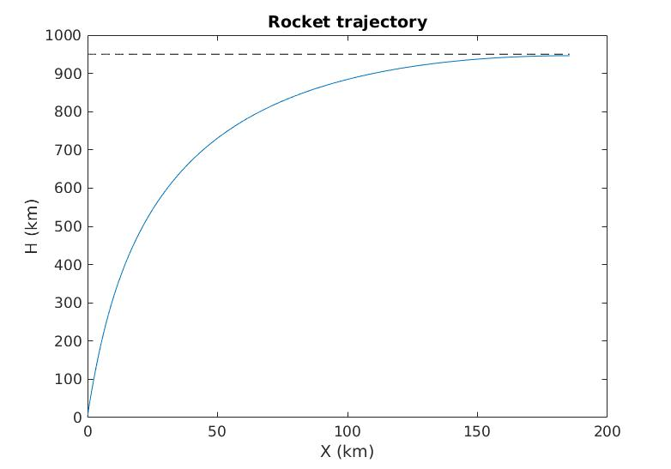

Fig. - Rocket trajectory and required altitude

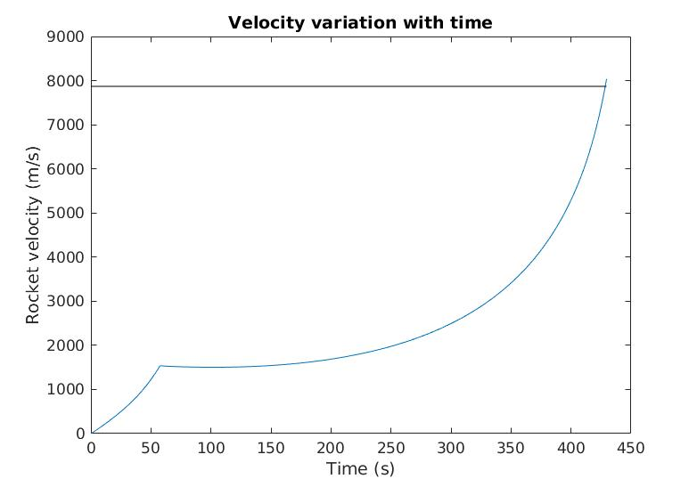

Fig. - Rocket velocity variation with time and required ΔV

## Satellite Design

The selected satellite is based on the SMART-OLEV project conducted by SSC (Sweden), Kayser-Threde (Germany) and Sener (Spain). The SMART-OLEV satellite was designed as an orbital life extension vehicle for commercial spacecraft already in GEO [12]. Thus the SMART-OLEV satellite is a suitable base for an ADR satellite as servicing missions have a lot in common with ADR missions. Both imply manoeuver between several objects in space and need a docking mechanism.

The SMART-OLEV satellite is a low-thrust satellite which docks to working satellites unable to manoeuvre themselves. After docking the servicing satellite performs the desired trajectory changes extending the life of the serviced satellite by several years. For ADR, the serviced objects will not be working satellite in GEO but debris in LEO. Debris are lighter than the GEO satellites considered when SMART-OLEV was designed but the ADR mission has to be achieved in a smaller time-frame. These differences have to be considered and an investigation on the suitable grabbing device and low-thruster is made here.

### Grabbing Device and Docking Mechanism

The function of the grabbing device is to link the satellite and the debris allowing precise relative manoeuvre of the satellite around the debris until docking. The chosen grabbing device is composed of a robotic arm and a gripper at the end of it. For the ADR mission, a relatively small size robotic arm is sufficient. However most of the available robotic arms available today are designed for heavier load (Canadarm, European Robotic Arm and Dextre for example). Therefore, the technology of small size arms is less mature. In recent years, three advanced robotic arms have either been successfully used in space mission or been being developed:

* OEDMS (Orbital Express Demonstration Manipulator System) which was used in Orbital Express mission conducted by the United States.
* DEOS which is still a conceptual robotic arm being developed by DLR.
* Frend arm which is also a conceptual manipulator under development. The following table shows some data for these three manipulators.

TABLE IV

Robotic ARMS CHARACTERISTICS

|  |  |  |  |  |  |
| --- | --- | --- | --- | --- | --- |
| Manipulator | DOF | Max  Length(m) | Mass(kg) | Max Power(W) | Stowed  Volume  (m3) |
| DEOS manipulator [13] | 7 | 3.23 | 40.5 | 100 | Unknown |
| Frend arm [14] | 7 | 2 | 78 | Unknown | 0.91 |
| OEDMS [21] | 6 | 3 | 71 | 131 | 0.59 |

Table IV shows the specifications of the various robot arms. DEOS manipulator is based on modified Rokviss module [13]. Equipped with a three fingers gripper, DOES is able to capture and hold a part of the rocket body during the berthing and docking process. There is also a vision system equipped on the gripper, which make the grabbing process more precise and faster. The maximum torque of the joint of the arm is 80Nm. Frend arm has a very high stiffness, which means the accuracy of this arm is also very high. Designed carefully, the cabling system of Frend eliminates the extra torques and snagging problems which are always associated with the use of wires [14]. This robotic arm has passed the vibration, thermal and EMI/MEC tests, and it has been proven to be very reliable and capable for on-orbiting service mission. OEDMS is a 6DOF manipulator, developed by MDA.

Finally, the OEDMS arm is chosen as it has already been used in contrary to the other two options. Reliability is the priority and the extra mass of the OEDMS is critical since the performances of the satellite is very good as discussed in the discussion section.

Although the SL-8 rocket bodies do not have interface designed for being grabbed by the service satellite, the configuration of their engine nozzles is suitable for being grabbed. Therefore, the convergent part of the nozzle is used by the gripper to grab the rocket bodies as shown in Fig. 2.

After grabbing the debris, the docking device is used in order to ensure a sturdy connection between the satellite and the rocket body. Ensuring that the application point of the force generated by the satellite thrust on the debris is on the vertical axis of the rocket body. As shown in fig.2, once the capture tool is inserted into the nozzle, the crown locking mechanism is deployed to keep a strong contact between the satellite and the rocket stage. The capture tool is also equipped with a vision system as the gripper does to detect the position of the nozzle and ensure the accuracy of the docking process. The SMART-OLEV docking mechanism is designed for small nozzle as found on GEO satellites and not for rocket bodies nozzle which are larger. The size of the ADR docking device need to be modified to suit the large nozzles of the rocket bodies.



Fig. - The docking process of the SMART-OLEV. (right: inserting, left: locking position) [15]

### Propulsion

Several available ion thrusters were compared based on their performance. For this feasibility study, the most powerful one is chosen with maximum performance: the BHT-8000. The characteristics of the chosen propulsion system are listed Table V.

TABLE V

BHT-8000 Characteristics

|  |  |
| --- | --- |
| Required power | $$10 kW$$ |
| Propellant | Xenon |
| Thrust | $$449 mN$$ |
| Isp |  |
| Mass | $$25 kg$$ |

### Sizing

The mass of the SMART-OLEV satellite is limited to one ton and one third of it is the propellant. The SMART-OLEV thus uses around $350 kg$ propellant. [12] This is approximately the same amount of propellant needed in this project.

The SMART-OLEV is using 6 hall-effect thrusters which are the same type as the SMART-1 satellite [12]: the PPS-1350-G thruster [15] has a mass of $5.30 kg$ and a nominal power of 1500 W [16]. Therefore, the satellite propulsion system weighs 32 kg and needs 9kW of electrical power. As a comparison, the Busek BHT-8000 has a mass of 25 kg and a nominal power of 8 kW [17].

The grabbing device chosen is similar to the one used for the SMART-OLEV. Thus, a similar mass is assumed as well.

The SMART-OLEV project concerns operating client satellite at the GEO. [12] Hence, the satellite is always receiving solar energy. But at the LEO, Earth may block sunlight. Therefore, the satellite needs a battery to maintain thrust. The satellite will be in Earth’s shadow for approximately half the orbit period. The orbit period can be calculated by the following equation according to the Kepler’s third law.

$$P=\sqrt{\frac{{4a}^{3}π}{GM}} ⇒$$

$$P_{max}=\sqrt{4×\frac{{\left(6400 km+1000km\right)}^{3}π}{GM}=}3574 s ≈1 hour$$

This value is computed with an altitude of 1000km. Considering the satellite will travel back and forth from this altitude to the optimal orbit, the longest unpowered time shall be half an hour. Thus, the battery needs to provide 8 kW for the thruster for half an hour. This represents an energy of $15MJ$ energy.

Let us call $M_{b}$ the mass of the battery, then the ratio of specific energy and the specific power of the battery should be the following.

$$\frac{15MJ}{M_{b}} / \frac{8kW}{M_{b}}≈2000$$

According to Cowie [18], the lithium nickel manganese cobalt oxide battery has a similar performance. The maximum battery mass is then computed with the following relation.

$$\max{(\frac{15MJ}{265Wh/kg},\frac{8kW}{340W/kg})= 23.5 kg}<30 kg$$

The mass of the battery is then insignificant. A total mass of 1 ton is then used for the study.

## Satellite Manoeuvring

The propulsion used is electrical propulsion with ion thrusters. These thrusters provide a significantly small thrust (tens to hundreds mN). Hence, only low thrust orbital transfers are possible.

### LEO Diameter

An object orbiting in low Earth orbits will eventually fall because of two different sources of drag, which are air and solar activity. Solar activity has two effects: solar drag (also known as the Poynting-Robertson effect) due to solar radiation, and space weather variation. A high solar activity can heat the local atmosphere and make it expand, inducing a higher density and thus a higher air drag.

Solar activity changes periodically and its magnitude is usually random. Hence, measuring the influence of solar activity on an object’s drag is complex on a long term basis. By neglecting solar activity, a simple formula giving decay life-time can be obtained as follows [Wiesel] ().

Assumptions:

* Air drag coefficient constant
* Exponential atmosphere
* No solar activity
* The debris is a perfect cylinder (Diameter: 2.4m ; Length: 6m)
* Circular orbit

The decay life-time is then given by:

$$t_{D}=\frac{hm}{ρ_{0}AC_{D}\sqrt{μR_{earth}}}(e^{\frac{H_{0}}{h}}-1)$$

With:

* $h=\frac{RT_{SSL}}{g0}$: The atmospheric scale height
* $A$: The cross sectional area
* $C_{D}$: The drag coefficient (0.82)
* $H_{0}$: Initial height
* $m$: Debris mass (1400kg)

Using this formula, a 25-year decay would be achieved for an initial height of 270km. Decay orbit is a chaotic phenomenon. Indeed, the decay life-time is extremely sensitive to the initial conditions. A slight variation of drag, compared to the simulation, can make the object decay several days later than the prediction. Hence, the previous analytical calculation cannot be defined as accurate. Furthermore, given the long decay lifetime targeted (25 years), solar activity cannot be neglected.

A more accurate study has been made by NASA, by taking into account the mean value of solar activity, but neglecting solar drag [NASA p.24]. Based on the studied debris’ Area-to-Mass contour (≈0.02), the optimal orbit would be 680km. By including a safety margin of 80km, the optimal orbit becomes 600km. This value has been kept for the project.

### Radius change

Let us denote $h$ and $θ$ respectively the height of the satellite (in the local horizontal frame) and the angle made by a random coplanar geostationary vector to the position vector. The satellite’s trajectory can be computed using Equations () and (). In a geometric point of view, it is a logarithmic spiral.

$$\frac{dh}{dt}=\frac{2T}{m}\sqrt{\frac{{\left(R_{earth}+h\right)}^{3}}{μ}}$$

$$\frac{dθ}{dt}=\sqrt{\frac{μ}{{\left(R_{earth}+h\right)}^{3}}}$$

$$\frac{dm}{dt}=-\frac{T}{gI_{sp}}$$

Using this equations, dragging a debris from its orbit to the optimal orbit (600km) takes approximately 11days for a $ΔV=977m/s$, while an optimal orbit to debris orbit trip takes 16.8days for the same $ΔV$.

### Inclination Change

The debris have different inclination. Furthermore, the Falcon 9 launch has an accuracy of $±0.1°$. Therefore, the satellite needs inclination changes.

The orbital mechanics equations of a satellite performing a inclination change are:

 (1)

where *r*(*x*, *y*, *z*) is the location of the satellite in the inertial frame, is the acceleration of it, *m* is the weight of it and *T*(*Tx*, *Ty*, *Tz*) is the thrust along the axis of the inertial frame. So the velocity of the satellite is

 (2)

and *T*, *r* and  need to meet the equation (3) in order to make the thrust perpendicular to the r and  plane

 (3)

Since the inclination changes required between the debris are small, the mass of the propellant can be considered constant throughout the manoeuvre. For an inclination change of 0.0163° which is the maximum inclination difference, the thrust only need to last 2.37h to complete this change, and the ΔV corresponding to this segment is 3.413m/s. The figure 1 is the inclination change orbit of the satellite.

Furthermore, for an inclination change of $0.1°$ (Falcon ) launch accuracy), the manoeuvre time is 12h, for a corresponding $ΔV$ of $20 m/s$.

### RAAN Change

The most effective way to change RAAN is performed by exploiting its natural drift. However, this technique is time consuming. For this mission, natural RAAN drift is neglected, and low-thrust RAAN transfer is used. This manoeuvre is performed by out-of-plane thrusting as explained in [19]. This paper gives the cost in $ΔV$ for near-circular orbit:

$$ΔV= \frac{π}{2}\sqrt{\frac{μ}{R}}\sin\left(i\right)|ΔΩ|$$

Where $μ$ is the earth standard gravitational parameter, $R$ is the satellite orbit radius, $i$ is the orbit inclination and $ΔΩ$ is the difference between the targeted RAAN and the satellite RAAN. The cost of each RAAN manoeuvre is given in section III.C The RAAN change is the most expensive in terms of fuel and time. Hence, minimizing RAAN manoeuvre should be the priority.

### Rendezvous Manoeuvre

After low thrust orbital transfers for radius, inclination and RAAN, the satellite is now at the exact same orbit as the debris, and at a close proximity. The distance between the two objects has to be closed using a rendezvous manoeuvre. The Clohessy-Wiltshire equations have been used to simulate this approach. However, these equations have been modified to suit the given study. To be more precise, thrust is not an impulse; the satellite constantly thrust either in the direction of its velocity, or either in the opposite direction (accelerate or brake).

Consider the satellite (S) and the debris (D), in the geostationary reference, as shown in Figure… Let us call $n$ the angular velocity of the debris (i.e. the angular velocity of an circular orbit of the same radius). Let us call $δr, δθ,$ and $δz$ the cylindrical coordinates describing the satellite’s position in the debris local frame. The satellite’s thrust is in the $e_{θs}$ direction and given by $T=Te_{θs}$ with T<0 or T>0 depending on if it accelerates or if it brakes.

TABLE VI

Overall $ΔV$ and $Δt$ for manoeuvres

|  |  |  |
| --- | --- | --- |
| Manoeuvres | $$ΔV$$ $$m/s$$ | $$Δt$$ |
| Orbit -> LEO | 4888 | 56 days |
| LEO -> Orbit | 4888 | 21 days |
| Inclination | 117 | 3.0 days |
| RAAN | 267.0 | 6.9 days |
| Rendezvous | 1.0 | 2100 seconds |
| Total | 10161 | 86.9 days |

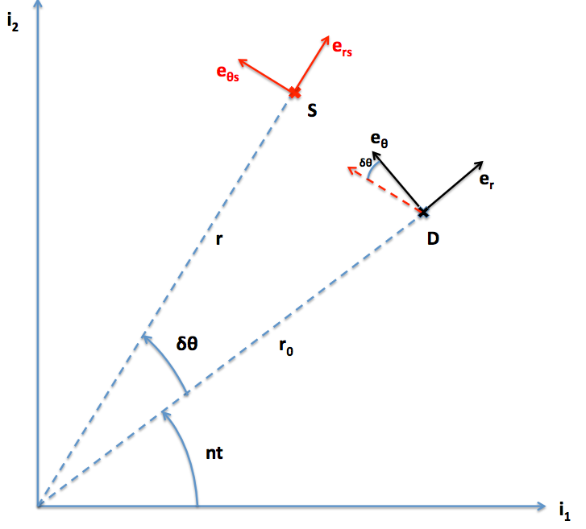

Fig. - Satellite and debris local frame with respect to the geostationary frame

The Clohessy-Wiltshire equations, describing the variation of the relative position of the satellite, are then:

$$\left\{\begin{aligned}δ\ddot{r}-2nr_{0}δ\dot{θ}-3n^{2}δr=-Tsin⁡(δθ) \\ r_{0}δ\ddot{θ}+2nδ\dot{r}=Tcos(δθ) \\ δ\ddot{z}+n^{2}δz=0\end{aligned}\right.$$

This equation is valid only if the relative coordinates of the satellite are small, and in a free space with only the influence of Earth. The satellite, the debris orbit and thrust, are assumed coplanar. Thus, the last equation is not used further in the study.

A rendezvous trajectory has been plotted on Figure… for an initial condition of $δx=1km$ in the $e_{θ}$ direction.

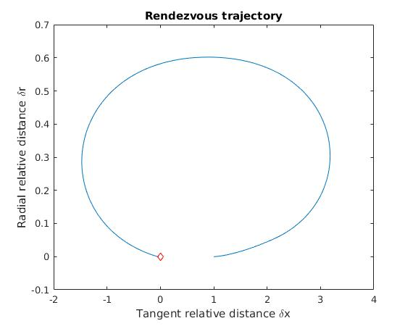

Fig. - Rendezvous trajectory of the satellite

# Discussion

The calculated mission duration is 86.9 days which is far less than the maximum allowed duration of the mission (1 year). Therefore, it is possible to choose less powerful thrusters for the mission: the current thrusters are cutting-edge and expensive, selecting less expensive thrusters would increase the mission duration but make it more affordable. In order to meet the objective in exactly a year, an ion thruster with a thrust of 120 mN can be used.

The rocket trajectory was computed with a payload mass of 1500kg. However, our satellite weighs only 1000kg. Thus, we are 500kg short. This difference can be either closed by launching another small satellite with ours, or changing the rocket.

The models used could be improved with more accurate assumptions: Earth oblateness, solar drag, elliptical orbits, etc.

The total cost of the project needs to be worked out.

# References

|  |  |
| --- | --- |
| [1] | M. Castronuovo, “Active space debris removal - A preliminary mission analysis,” *Acta Astronautica 69,* pp. 848-859, 2011. |
| [2] | J.-C. Liou and N. L. Johnson, “Instability of the present LEO satellite,” *Advances in Space Research 41,* pp. 1046-1053, 2008. |
| [3] | D. J. Kessler and B. G. Cour-Palais, “Collision frequency of artificial satellites: The creation of a debris belt,” *Journal of Geophysical Research: Space Physics,* vol. 83, no. A6, pp. 2637-2646, 1978. |
| [4] | J.-C. Liou and N. L. Johnson, “A sensitivity study of the effectiveness of active debris removal in LEO,” *Acta Astronautica 64,* pp. 236-243, 2008. |
| [5] | F. Covello, “Application of electrical propulsion for an active debris removal system: a system engineering approach,” *Advances in Space Research,* vol. 50, no. 7, pp. 918-931, 2012. |
| [6] | J.-C. Liou, “An active debris removal parametric study for LEO,” *Advances in Space Research 47,* pp. 1865-1876, 2011. |
| [7] | B. B. Virgili and H. Krag, “Strategies for active removal in LEO,” in *5th European Conference on Space Debris*, Darmstadt, 2009. |
| [8] | Joint Space Operations Center, USAF, “Space-Track.Org,” [Online]. Available: space-track.org. [Accessed 15 09 2016]. |
| [9] | B. Leitenberger, Raketenlexikon Band 2: Internationale Tragerraketen, Books On Demand, 2009. |
| [10] | U. S. A. F. National Aeronautics and Space Administration, “U.S. Standard Atmosphere,” USAF, 1976. |
| [11] | P. Blau, “Falcon 9 v1.1 & F9R Launch Vehicle Overview,” Spaceflight101, [Online]. Available: http://spaceflight101.com/spacerockets/falcon-9-v1-1-f9r/. [Accessed 03 10 2016]. |
| [12] | F. S. M. D. E. Clemens Kaiser, “SMART-OLEV – AN ORBITAL LIFE EXTENSION VEHICLE”. |
| [13] | Q. M. P. Rank, “THE DEOS AUTOMATION AND ROBOTICS PAYLOAD,” NOORDWIJK, 2011. |
| [14] | S. P. D. Thomas J. Debus, “Overview and Performance of the Front-End Robotics Enabling Near-Term Demonstration (FREND) Robotic Arm,” in *AIAA*, Seattle, 2009. |
| [15] | P. B. S. P. P. R. Joakim Kugelberg, “Accommodating electric propulsion on SMART-1,” *Acta Astronautica,* vol. 55, no. 2, pp. 121-130, 2004. |
| [16] | S. Snecma, “PPS®1350-G STATIONARY PLASMA THRUSTER,” SAFRAN Snecma. |
| [17] | S. P. a. S. Busek, “BHT-8000 Busek Hall Effect Thruster,” Busek, Space Propulsion and Systems, Natick, 2016. |
| [18] | I. Cowie, “All About Batteries,” MaxVision, 13 1 2014. [Online]. Available: http://www.eetimes.com/author.asp?section_id=36&doc_id=1320644; http://www.eetimes.com/author.asp?section_id=36&doc_id=1321416; http://www.eetimes.com/author.asp?section_id=36&doc_id=1321938. [Accessed 6 10 2016]. |
| [19] | J. Pollard, “Simplified Analysis of Low-Thrust Orbital Maneuvers,” The aerospace corporation, El Segundo, California, 2000. |
| [20] | F. S. J. M. D. B. E. Clemens Kaiser, “SMART-OLEV – AN ORBITAL LIFE EXTENSION VEHICLE FOR SERVICING COMMERCIAL SPACERAFTS IN GEO”. |
| [21] | J. A. M. H. J. L. Andrew Ogilvie, “Autonomous Satellite Servicing Using the Orbital Express Demonstration Manipulator System,” DARPA, Canada. |
| [22] | “Ariane5 Users Manual,” July 2011. [Online]. Available: http://www.arianespace.com/wp-content/uploads/2015/09/Ariane5_users_manual_Issue5_July2011.pdf. [Accessed 07 10 2016]. |
| [23] | “Falcon 9 v1.1 & F9R – Rockets,” 03 10 2016. [Online]. Available: http://spaceflight101.com/spacerockets/falcon-9-v1-1-f9r/. |
| [24] | “GSLV Mk.II – Rockets,” Spaceflight101 – Space News and Beyond, [Online]. Available: http://spaceflight101.com/spacerockets/gslv-mk-ii/. [Accessed 7 October 2016]. |
| [25] | “Proton M Launch Vehicle,” Khrunichev State Research and Production Space Center, [Online]. Available: http://www.khrunichev.ru/main.php?id=42. [Accessed 29 09 2016]. |
| [26] | “Spaceflight101 – Space News and Beyond,” [Online]. Available: http://spaceflight101.com/spacerockets/long-march-2f/. [Accessed 7 October 2016]. |
| [27] | “ISCK documents,” [Online]. Available: http://www.kosmotras.ru/en/docs_mkk/. [Accessed 07 October 2016]. |
| [28] | SpaceX, “Falcon_9_Users_Guide_rev02,” 21 10 2015. [Online]. Available: http://www.spacex.com/sites/spacex/files/falcon_9_users_guide_rev_2.0.pdf. [Accessed 03 10 2016]. |
| [29] | M. Wade , “Vandenberg,” [Online]. Available: http://www.astronautix.com/v/vandenberg.html. [Accessed 7 October 2016]. |